TECHNICAL SITE SURVEY REPORT

SITE NAME: | Click or tap here to enter text.
SITE ID: | Click or tap here to enter text.
Site Model: | Site Type: | Choose an item.
CUSTOMER: | ice
Site Owner: | Choose an item.
Available Supporting document versions: | Site Owner Offer Select | Montasjeunderlag Select
Available Supporting document versions: | SART Select | Veiviser Select
Available Supporting document versions: | RFSR/RNP Select
Available Supporting document versions: | Guideline Version: Click or tap here to enter text.
Veiviser / Site Access info
Veiviser update Comments: | if yes, please add comment here (access, keys, contact person, parking, photos, other relevant info)  If no, write "N/A"
iLOQ info | Specify where iLOQ is to be installed, equipment room, access ladder, etc. See doc on “Spec and guidelines” for more details on when and where to install iLOQ.

TSSR Alignment with SART, MU, RNP. RFSR Choose an item.
Comments
Click or tap here to enter text.
REVISION HISTORY
Rev. | Nr. | Name | Company | Type | Date
00 | 00 | Click or tap here. | Click or tap here. | Select | Select
00 | 00 | Click or tap here. | Click or tap here. | Select | Select
00 | 00 | Click or tap here. | Click or tap here. | Select | Select
00 | 00 | Click or tap here. | Click or tap here. | Select | Select

Work Scope Specific transportation and SHA/HSE considerations

- description of PLANNED WORKS

Safety on roof/mast:
- SJA to be filled out for all jobs before work is conducted. If conditions on site change, a new SJA must be filled out.
- See chapter 1.2 for more details.

Site room:

Transmission:

AC Distribution:

Cables and cable route between site room and antennas:

Antenna mounts:
Sector A:

Sector B:

Sector C:

Other tasks:
- Do cleanup and ASBUILT.
- Do walk test after site is integrated.
- Update group chart for ACDB make new group chart for DCDU.
- Take pictures inside/open connector, of every DC connector for As Built Documentation.
- Provide pictures of antenna mounts and all reinforcements made to the wall mounts in the ABD documentation.
- When installing or modifying an ICE rectifier: make sure to deliver filled in and signed off document, ICE Rectifier Alarm testing Rev 4.1, as part of the asbuilt documentation.

  - DeliverY
Delivery |  | Time of year:  Summer☐  Winter ☐ |  | Personell:  Car ☐  Foot☐  ATV ☐  Snowmobile☐ |  | Equipment:  Car ☐  ATV ☐  Snowmobile ☐  Helicopter ☐
 |  | Comments:
Crane?
YES☐ NO☐
If “Yes” fill in below and attach illustration
Distance of crane deployment point from the building |  |  |  |  | Click or tap here to enter text.
Crane company name and org. Nr.:
Roadblock required?
YES☐ NO☐
Helicopter
YES☐ NO☐
Requested Landing Coordinates |  |  | Lat: 00.00000 | Long: 00.00000
Comments
Approach GF; ATV, Snow mobile and by foot – attach map illustration of parking, route, conditions and critical safety spots:

  - SHA/HSE – Health & Safety Risk assessment
Site Category: Rooftop ☐ Greenfield/Siteshare ☐ BARN ☐ INDOOR/tunnel☐
If ROOFTOP or BARN method description for work at height shall be attached
All Lyse Tele projects on rooftops/barns require a method description for work at height specific to the site in the form of an illustration. The level of detail must reflect the complexity and hazard level of the site and clearly show the placement and type of measures to be implemented. Method description shall include all activity on the site.
Site specific hazards: |  | List
Site specific risk mitigating measures: |  | List
List the HSE procedures/instructions needed for planned works: |  | List doc title and/or doc ID
Any special safety requirements from landlord? IF “YES”, detail below |  | Yes
Any additional information/illustrations: | Detailed illustrations, attach if too big

  - List of contractors on site: e.g. crane/scaffolding/electrician etc.
Submit using the document Appendix TSSR_A1 prior to start of works. Update as needed
Untitled folder - ICE (documaster.com)

- SITE INFORMATION – Existing Situation
  - Building & Roof(top) Choose an item.
Building | Type: Choose an item.
Building | Facade material: Choose an item.
Building | Height (m): Click or tap here to enter text.
Roof | Type: Select
Roof | Material: Select
Remarks | Click or tap here to enter text.
  - Shelter/Equipment Room Choose an item.
Dimensions | Length: Value (m) |  | Width: Value (m)
Dimensions | Height: Value (cm) |  | Cable ladder height: Value (cm)
Material | Floor: Select | Wall: Select |  | Ceiling: Select
Remarks | Click or tap here to enter text.
  - REQUIRED SITE INFORMATION (TOWER) Choose an item.
Tower type | Choose an item. |  |  |  |  | First Section ID.: 00(for known tower types)
Tower height | Tower Height: 0.0 (m) |  |  |  |  | Total Nr. Of tower Sections: 00
Tower Diameter | Only if applicable (like concrete cylinder or monopoles)
Tower Diameter | Bottom: 0.0 (cm) |  |  |  |  | Antenna level: 00 (cm)
Tower leg | Type: |  | Choose an item.
Tower leg | Bottom level leg size: |  |  |  | 0.0 (cm) |  | Leg distance: 00 (cm)
Tower leg | BOA leg size: |  |  |  | 0.0 (cm) |  | Leg distance: 00 (cm)
Tower leg | TOA leg size: |  |  |  | 0.0 (cm) |  | Leg distance: 00 (cm)
Vertical cable route | Availability: Choose an item.
Vertical cable route | Bottom of the vertical route: 0.0 (m)
Vertical cable route | clamp type: | Select |  | Free space (cm): |  |  | 00
Horizontal cable tray | Availability: Choose an item.
Horizontal cable tray | length: | 0.0 (m)
Horizontal cable tray | clamp type: | Select |  | Free space (cm): |  |  | 00
Remarks | Click or tap here to enter text.
  - Main AC/Power Meter and GND Choose an item.
Location of main breaker (before EDP) | Click or tap here to enter text. |  |  | Distance from ACDB: Value (m) (m)
Main Breaker (before EDP) | Click or tap here to enter text. (A)
Earthing System | Choose an item.
Free AC breakers | Position: | 00 | Size: |  | 00 (A)
Space for new breaker | Choose an item.
Type of AC Breakers | Click or tap here to enter text.
Main GND | Location: Click or tap here to enter text.
Main GND | Remarks: Click or tap here to enter text.
Remarks | Click or tap here to enter text.
- CW, Power and GND INSTALLATIONPower
  - Power
Power Meter - Choose an item.
To be Installed by |  | Choose an item.
Location: |  | Click or tap here to enter text.
possibility for own power subscription: |  | Choose an item.
Power Application sendt to Power grid owner: |  | Choose an item.
ACDB - Choose an item.
Type: |  | Choose an item.
Location: |  | Click or tap here to enter text.
Comments: |  | Click or tap here to enter text.
Rectifier - Choose an item.
Cabinet Type |  | Choose an item.
SPD Type: |  | Choose an item.
Flatpack2 Type: |  | Choose an item.
Comments: |  | Click or tap here to enter text.
Battery
Backup Requirement: Choose an item.
Nr. of Strings: | 0 (pcs) |  | Capacity: | 0 (Ah)
Remarks: | Click or tap here to enter text.
  - Ventillation/Cooling Choose an item.
Type: | Choose an item.
Location: | Click or tap here to enter text.
Remarks: | Click or tap here to enter text.
  - Cable Inlet Choose an item.
Existing Available | Select | Existing Flange | Select | Type: Select
New inlet needed | Choose an item.
Remarks: | Click or tap here to enter text.
  - Antenna and Cabinet Mounts - Choose an item.
ID | Sectors |  |  |  |  | Type | Product | Ballast Amount
ID | A | B | C | D | E | Type | Product | Ballast Amount
AM1 | ☐ | ☐ | ☐ | ☐ | ☐ | Select | Specify | Nr.
AM2 | ☐ | ☐ | ☐ | ☐ | ☐ | Select | Specify | Nr.
AM3 | ☐ | ☐ | ☐ | ☐ | ☐ | Select | Specify | Nr.
XXN | ☐ | ☐ | ☐ | ☐ | ☐ | Select | Specify | Nr.
OD Cabinet mount: |  |  |  |  |  | Select | Specify | Nr.
Remarks: |  |  |  |  |  | Click or tap here to enter text.

  - AC, main DC and GND Cabling Choose an item.
Source | Cabling |  |  |  |  |  | Termination
Source | Type | Size (mm^2) | Length (m) | Core Drilling  needed | Fire Selaing  needed | New Inlets needed | Termination
Power Meter | Click or tap here | Click or tap here | Click or tap here | Click or tap here | Click or tap here | Click or tap here | ACDB
ACDB | Click or tap here | Click or tap here | Click or tap here | Click or tap here | Click or tap here | Click or tap here | Rectifier Main
ACDB | Click or tap here | Click or tap here | Click or tap here | NA | NA | NA | Main GND
Main GND Bar | Click or tap here | Click or tap here | Click or tap here | Click or tap here | Click or tap here | Click or tap here | Click or tap here
Click or tap here | Click or tap here | Click or tap here | Click or tap here | Click or tap here | Click or tap here | Click or tap here | Click or tap here
Remarks: | Click or tap here to enter text.
  - System and RF Modules
Module |  | DC Cable |  |  |  |  | OVP
Type | Sector | Cabinet/PDU | Breaker Nr. | Breaker Size (A) | Length  (m) | Size  (mm²) | OVP
AZHN L26 | ID | Enter cabinet/PDU ID | Nr. | (A) | 0 | 0 | DCDU
AHPMDH | ID | Enter cabinet/PDU ID | Nr. | (A) | 0 | 0 | DCDU
AHGB | ID | Enter cabinet/PDU ID | Nr. | (A) | 0 | 0 | Choose
Choose an item. | ID | Enter cabinet/PDU ID | Nr. | (A) | 0 | 0 | Choose
Choose an item. | ID | Enter cabinet/PDU ID | Nr. | (A) | 0 | 0 | Choose
Choose an item. | ID | Enter cabinet/PDU ID | Nr. | (A) | 0 | 0 | Choose
Choose an item. | ID | Enter cabinet/PDU ID | Nr. | (A) | 0 | 0 | Choose
Choose an item. | ID | Enter cabinet/PDU ID | Nr. | (A) | 0 | 0 | Choose
Choose an item. | ID | Enter cabinet/PDU ID | Nr. | (A) | 0 | 0 | Choose
Choose an item. | ID | Enter cabinet/PDU ID | Nr. | (A) | 0 | 0 | Choose
Remarks: | Click or tap here to enter text.

3.7 Fiber/RET
Cable / OCB |  | Optical fibres
Type | ID | Cabinet/RRH/RET | Amount  Nr.
ATOA OCB |  |  | 1
G24 40m OD to OD
G2 2m OD to OD
RET Cable 2m
Choose an item.
Choose an item.
Choose an item.
Choose an item.
Remarks: | Click or tap here to enter text.

3.8 CW and Power Summary
Work Description | Click or tap here to enter text.
Extra Work Select | Click or tap here to enter text.

- TI INSTALLATION
  - RFM/RRH and SM INFORMATION
Cabinet Type | Choose an item.
System Module Type | Choose an item.
System Module Location | Click or tap here.
Number of new BB Cards | ABIO: Nr. | ASIB: Nr.
New RF/RRH locations | Choose an item.
Remarks | Click or tap here to enter text.
  - TRM INFORMATION
TRM Equipment Type | Click or tap here to enter text.
Location | Click or tap here to enter text.
Port | Click or tap here to enter text.
Connector Type | Click or tap here to enter text.
Distance | Click or tap here to enter text.
SFP Type | Click or tap here to enter text.

  - TI Installation Summary (DOUBLE CLICK TO EDIT TABLE) copy past from RNP
Work Description: | Click or tap here to enter text.
Extra work Select | Click or tap here to enter text.

- Drawings
  - Antenna Directions:
Comment: Insert Antenna azimuth referance point pictures here (A/B/C). To be provided by SPL.
Comment: Click or tap here to enter text.

  - Antenna direction requirements and installed height (if applicable)
Comment:
Insert sketch of antenna height and distance from roof edge and Insert 120 deg antenna shooting directions photos taken from planned antenna position

example sketch
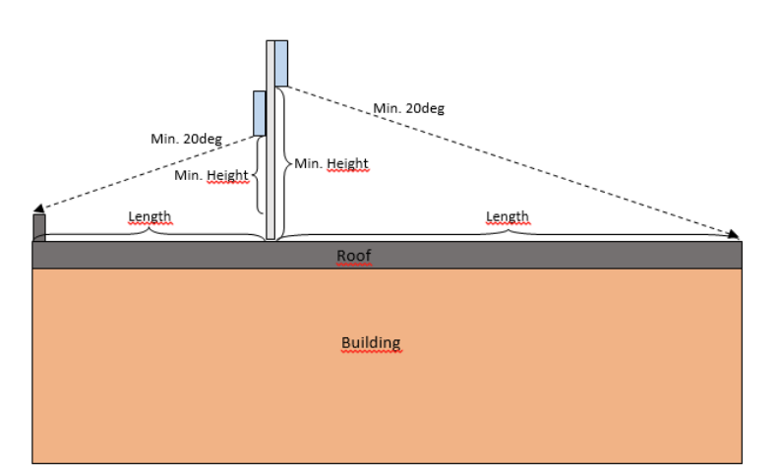

  - Equipment Room/Shelter Overview
Site category: Rooftop ☐ new Greenfield ☐ SITESHare ☐ BARN ☐ INDOOR☐ tUnneL ☐
Check the box for the type of site to be built
Comment: Click or tap here to enter text.

  - Site Plan (if applicable)
Insert a skecth (bird view) drawing of cabinet, power boxes, antenna mounts, cable route, placment/position of all other antennas

example sketch
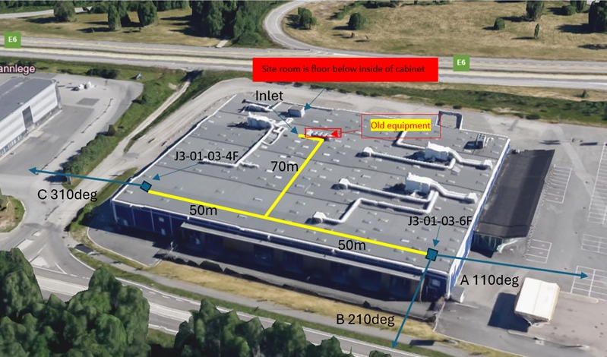

  - Screenshot of MAFI ESICS Result OR Cuedee DRAWING(graviation pole solution)
Comment: Click or tap here to enter text.

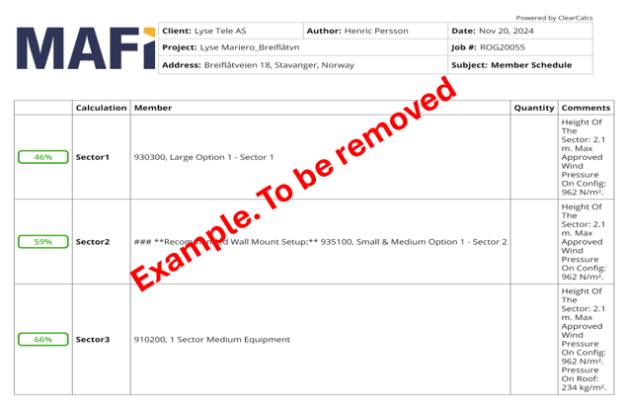

- Appendix
Content: Click or tap here to enter text.
Comments: Click or tap here to enter text.
Unrestricted editing below this line

Diagram on how to correctly connect between RRHs and antennas. The picture depicts the only solution for how to do it. Plus and minus within same frequency band can not be mixed/swapped.

Low band/AHMPDB: ANT1 -> R1+45, ANT2 -> R2+45, ANT3 -> R1-45, ANT4 -> R2-45
High band/AHEGB: ANT1 -> Y1+45, ANT2 -> Y2-45, ANT3 -> Y1-45, ANT4 -> Y2+45

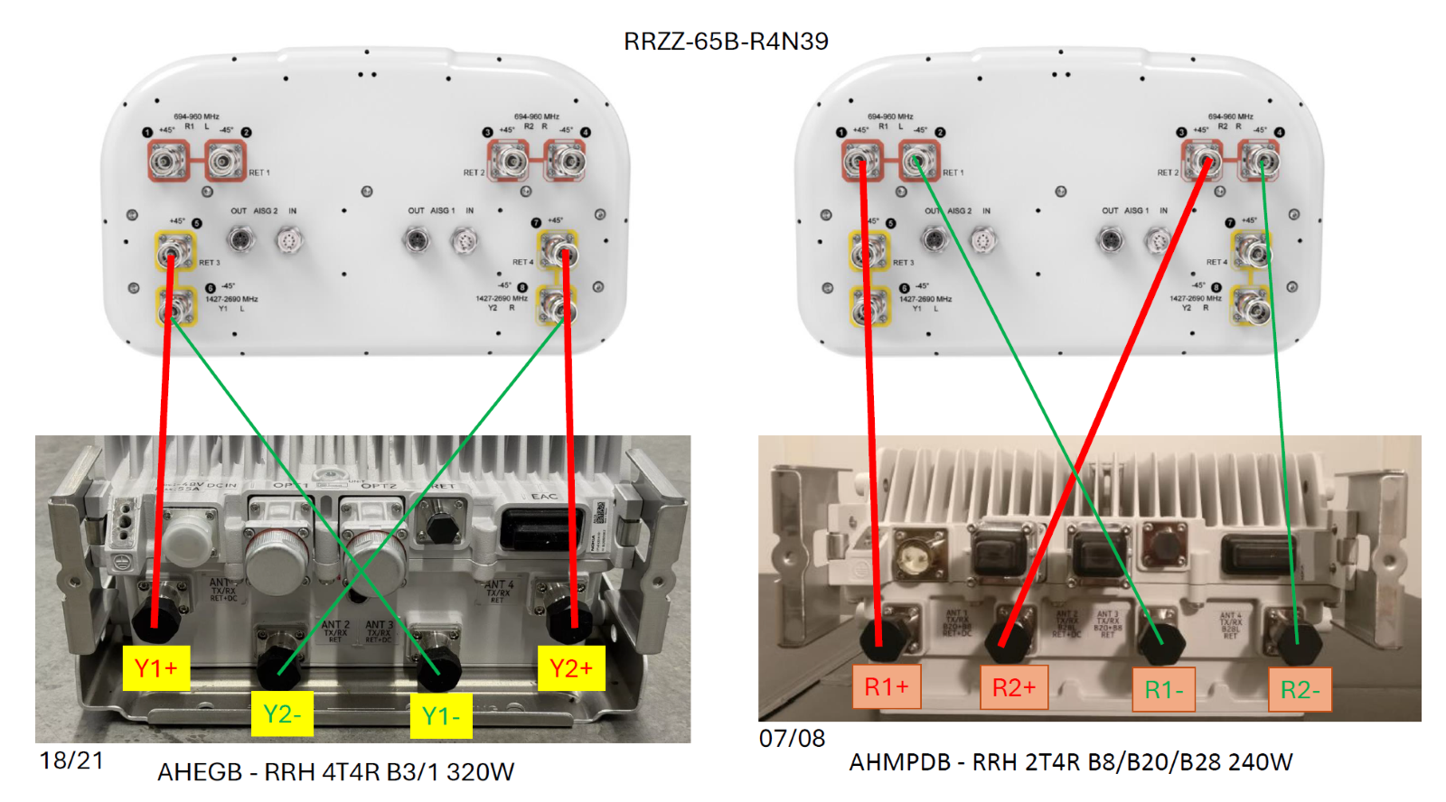
Applicable for both 65B and 65A antennas.

